Defensive Pistol Match

April 30

On April 30th, Dothan Practical Shooters will run a defensive pistol match. This match is designed to be very approachable to people who have never shot a match before. You can use almost any handgun you want, and you don’t even need a holster. Round count will be less than 100 rounds. Scoring method is simply time plus penalties.

We will have 5 pistol only stages and one stage that will use pistol and a rifle with shots out to 100 yards. We will have a rifle available on the stage for you to use, but ammunition must be purchased from the pro shop (cost TBD). Less than 20 rounds rifle required. There will also be a stage utilizing the 270 degree shoot house.

The match will be conducted under the direction of trained and experienced range officers.

Questions? Please contact Drew at [DothanPracticalShooters@gmail.com](mailto:DothanPracticalShooters@gmail.com)

Scan the QR code to register on PractiScore (requires a free account), or you can email Drew to be registered.

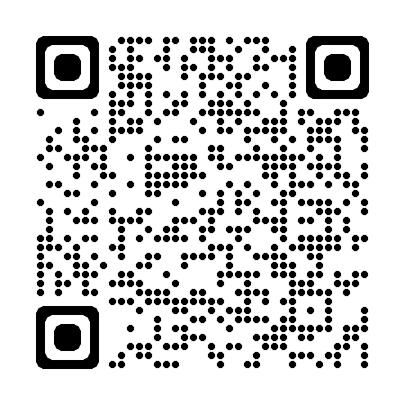

**Brief Rule Overview**

Scoring is time from start signal to last shot fired, with a shot timer. Then penalties, in the form of added time, are tallied. Your total time is your score.

**Penalties:**

* No shoots – targets marked with an X or some other marking. Hitting one of these is a 60 second penalty
* Failure to Neutralize – failing to neutralize a target with the required hits is a 30 second penalty
* Failure to Engage – failing to shoot at a target will incur a 45 second penalty (does not stack with failure to neutralize)
* Procedurals – 15 second penalty for things like failing to comply with a stage procedure

**Target Scoring:**

For a target to be considered neutralized, you must achieve a minimum of 8 points on the target (or amount specified on the stage briefing, the default/most common is 8). A single hit in the head box A-zone will also count as neutralized, regardless of any other hits.

* Targets are divided into scoring zones – A – 5 points, C – 3 points, D – 1 Point
* Scoring line hits – unlike in USPSA or other matches, where touching a scoring line counts for the higher zone, we will do the opposite. Touching a scoring line will count for the LOWER scoring zone

“Shoot throughs” where a bullet passes through a prop or target into a target will count for score or penalty, whatever the case may be.

Questions? Please contact Drew at [DothanPracticalShooters@gmail.com](mailto:DothanPracticalShooters@gmail.com)